**Q1:** Differentiate compiler and interpreter

**Ans:**Compilers and interpreters are the primary tools used to translate high-level, human-understandable programming languages into low-level machine code that a computer's central processing unit can execute. While both serve the same ultimate goal of code translation, they differ fundamentally in their processing methods, execution timing, and error-handling capabilities.

**Fundamental Processing and Input Handling**

The core distinction between the two lies in how they read the source code: a compiler takes the entire program as a single input and converts it into machine code all at once. Conversely, an interpreter takes just one line of the program as input at a time and converts that specific instruction into machine code before moving to the next. Because a compiler processes the whole file, it can analyze the logic across the entire application before any execution begins. An interpreter, however, operates line-by-line, meaning it must translate each instruction as it encounters it during the program's run.

**Translation Timing and Intermediate Products**

For a compiled language, the translation phase is a distinct step that must be completed entirely before the program can be run. This process typically generates an intermediate product known as an object file (.obj), which contains the machine-readable version of the code. Interpreters do not create an intermediate object code file; instead, they perform the translation and execution simultaneously. In the case of Python, the interpreter creates "byte-code," which is a platform-independent format that is then translated into something the host operating system can understand by a language-specific virtual machine.

**Execution Speed and Optimization**

Programs that are compiled generally offer faster execution of control statements and overall higher performance compared to those that are interpreted. This is because the compiler has the opportunity to optimize the code for the specific hardware environment during the initial compilation step. Interpreted languages are often slower because the computer must perform translation tasks while the program is running, which adds overhead. For example, in a language like Python, the runtime must work harder to inspect objects to determine their types before performing operations, whereas a compiled language like Java handles variable types and declarations during the build process.

**Memory Usage**

Compilers and interpreters have different impacts on system resources: a compiler requires more memory during its operation because it must create and store the resulting object code files. Interpreters are more memory-efficient in this regard because they bypass the creation of intermediate object files and execute instructions directly in sequence.

**Error Detection and Debugging**

The error-reporting mechanisms of these two tools create very different workflows for developers:

* **Compiler:** It identifies and displays errors only after the entire program has been read and analyzed. This means a programmer may have to wait for a lengthy compilation process to finish before seeing a list of syntax or logic errors.
* **Interpreter:** It detects and displays errors immediately after each individual instruction is read. This behavior makes debugging much easier and more intuitive, as the programmer is notified of the exact line where a failure occurred as soon as the interpreter reaches it.

**The Development Lifecycle**

The choice between a compiler and an interpreter significantly affects the speed of software development:

* **The Compiled Cycle:** Developers often find themselves in a "compile-fix-compile" loop, which can take minutes or even hours depending on the size of the project. While compilers catch many errors before runtime, the process of waiting for the code to build can be tedious.
* **The Interpreted Cycle:** Languages like Python facilitate a very rapid "edit-test-debug" cycle. Because there is no separate compilation step, the code can be run as often as necessary while fixing errors, making the development process much faster. For many modern software products, minimizing developer time is considered more important than maximizing computer processing speed.

**Portability and System Dependencies**

Compiled machine code is usually "portable" in theory but must be recompiled from raw source code for every unique computer system or target operating system. This means the programmer must generate different versions of the compiled code for each environment they wish to support. Interpreted languages are truly "system agnostic" because the intermediate byte-code they produce can run on any operating system that has the appropriate virtual machine installed. The programmer does not need to perform any special steps to make the software run across different platforms.

**Examples of Each**

Commonly used compiled languages include C, C++, and Java. Languages that traditionally rely on an interpreter include BASIC, Python, PHP, and JavaScript. Some modern languages, such as Java, use a hybrid approach where source code is compiled into byte-code and then processed by an interpreter or virtual machine to ensure cross-platform compatibility.

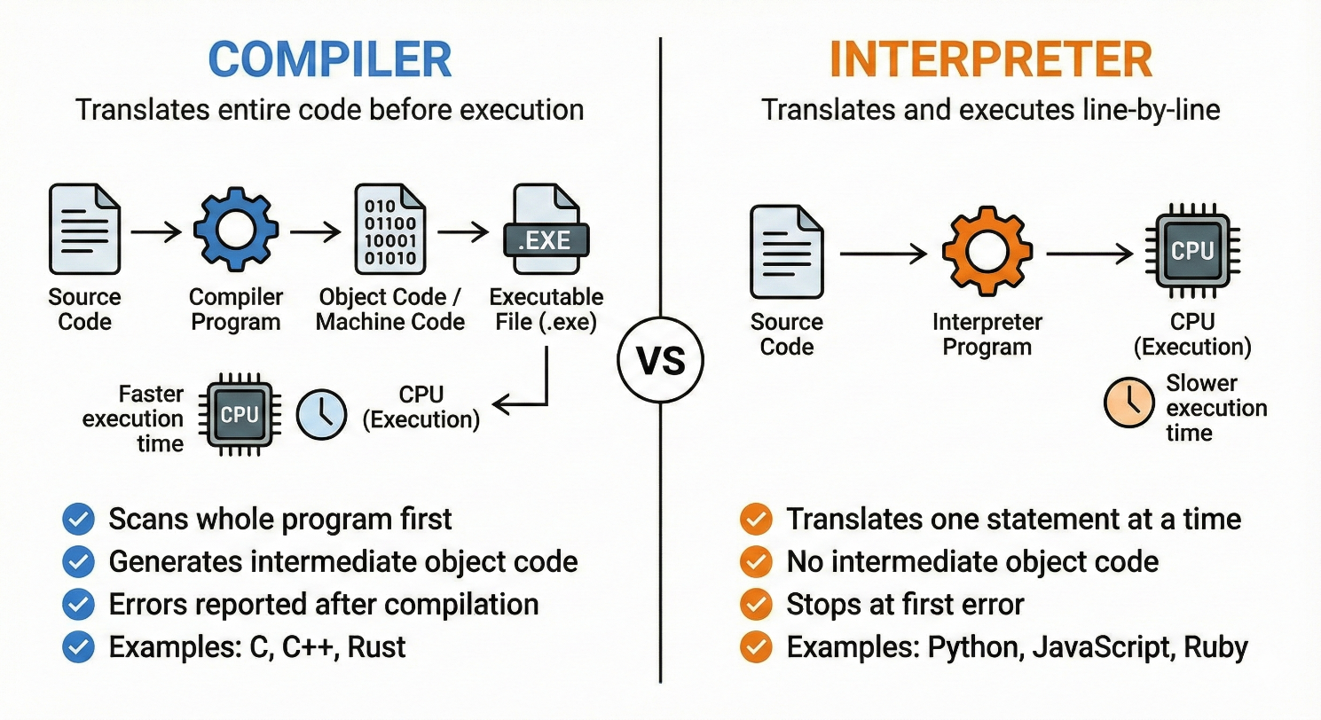

**Tabular From:**

|  |  |  |
| --- | --- | --- |
| **Feature** | **Compiler** | **Interpreter** |
| *Input Processing Method* | A compiler processes the entire source code of a program as a single unit before any translation begins. It reads the whole file to understand the logic and structure of the application. | An interpreter processes the program sequentially, taking only one line of code or a single instruction as input at a time. |
| *Intermediate Code Generation* | The compilation process usually generates an intermediate product known as an object file (with a .obj extension), which contains the machine code version of the program. | Interpreters generally do not create permanent intermediate object code files. For example, Python’s interpreter generates "byte-code" in memory, which is then handled by a virtual machine. |
| *Execution Timing* | Translation is a separate, distinct phase that must be fully completed before the program can be executed. | Translation and execution occur simultaneously; the interpreter translates a line and immediately executes it before moving to the next. |
| *Performance and Speed* | Compiled programs typically offer faster execution of control statements because the code is pre-optimized for the specific hardware environment during the compilation step, | Execution is generally slower because the computer must spend processing power on translation tasks while the program is actively running. |
| *Memory Usage* | Compilers require significant memory resources during operation because they must generate and store the resulting intermediate object code files. | Interpreters are more memory-efficient as they do not need to create or store large intermediate object code files on the disk. |
| *Error Detection and Reporting* | Errors are only identified and displayed after the compiler has finished reading and analyzing the entire program, this may lead to a long list of errors presented all at once. | Errors are detected and reported immediately after each instruction is read. This makes it easier to pinpoint the exact line where a failure occurred during runtime. |
| *Development Lifecycle* | Developers follow a "compile-fix-compile" cycle, which can be time-consuming because they must wait for the entire program to rebuild after every minor fix. | Interpreters facilitate a rapid "edit-test-debug" cycle because there is no separate compilation step, allowing the code to be run immediately after changes. |
| *Portability and Dependencies* | Machine code produced by a compiler is specific to a particular computer system or operating system and must be recompiled for every new target environment. | Interpreted languages are often "system agnostic" because the byte-code they produce can run on any OS that has the required language-specific virtual machine installed. |
| *Programming Language Examples* | Common examples include C, C++, and Java | Common examples include BASIC, Python, PHP, and JavaScript. |

**Summary**

* **Compiler:** Translates the entire program to machine code in one go, producing an executable. Results in faster runtime performance (since machine code runs natively), but requires a complete compile step and recompilation on changes. Examples of compiled languages include C, C++, and C#.
* **Interpreter:** Translates and executes code statement by statement at runtime. No separate compile step is needed. This allows quick testing and debugging (errors show up immediately), but each run may be slower. The Python interpreter (CPython) works this way, as do languages like Ruby and Perl.

**Q2:** Differentiate procedural and object-oriented programming.

**Ans:**

Procedural programming and object-oriented programming (OOP) represent two fundamental approaches to organizing software logic and structure. While both methodologies aim to solve computing problems, they differ significantly in their philosophy, data handling, and extensibility.

**Core Philosophy and Structure**

The primary difference between the two lies in how a program is divided and executed.

* **Procedural Programming:** This approach follows a **top-down** methodology where a program is divided into small, manageable parts called functions. It is fundamentally based on the concept of a sequence of steps or a "procedure" to be followed to reach a result. In this paradigm, the **function** is considered more important than the data it processes. Historically, languages like C utilized this approach to organize code into a series of top-down functional calls.
* **Object-Oriented Programming (OOP):** OOP follows a **bottom-up** approach where the program is divided into small parts called objects. These objects act as containers that encapsulate both data and the methods (functions) that operate on that data. Unlike procedural programming, OOP treats **data** as more important than the individual functions. Python borrowed these concepts largely from C++.

**Data Management and Security**

How data is protected and accessed is a major point of divergence between the two paradigms.

* **Data Hiding and Security:** Procedural programming does not have a proper mechanism for hiding data, which generally makes it less secure. Because functions operate globally on data, it is difficult to restrict access. Conversely, OOP provides robust **data hiding** through encapsulation, making it significantly more secure. It utilizes **access specifiers** such as private, public, and protected to control which parts of a program can interact with specific data.
* **Encapsulation:** In OOP, data and methods are grouped together within classes. This allows the internal state of an object to be "private" (often indicated in Python with a leading underscore) while providing specific "getters" and "setters" or properties to safely interact with that data.

**Flexibility and Code Reuse**

Maintenance and the ability to extend code are areas where OOP offers distinct advantages in complex systems.

* **Extensibility:** In procedural programming, adding new data and functions is not easy and often requires significant rewriting of existing code. OOP makes adding new data and functions much easier because of its modular nature.
* **Inheritance:** A unique feature of OOP is inheritance, where a **subclass** (child) can inherit the attributes and methods of a **superclass** (parent). This allows developers to modify or specialize a program’s behavior by adding new components rather than rewriting existing ones.
* **Overloading and Polymorphism:** Procedural programming generally does not support **overloading**, which is the ability to use the same operator or function name for different types of data. OOP supports both operator and function overloading, allowing objects to respond to built-in operations (like addition or slicing) in custom ways defined by the programmer.

**Real-World Modeling**

The paradigms differ in how they represent logic relative to the physical world.

* **Logic Representation:** Procedural programming is often described as being based on the "unreal world," focused purely on the logical steps of the computer. OOP is based on the "real world," allowing programmers to model physical objects—such as a tire, a car, or a storage tank—as specific class instances. This makes it easier for developers to conceptualize complex systems.

**Python’s Multi-Paradigm Approach**

It is important to note that Python is a **multi-paradigm** language. It allows developers to use procedural techniques (functions) or object-oriented techniques (classes) as they see fit. While functions are excellent for repeating specific tasks without copying and pasting code, classes provide a powerful way to organize related code blocks and data into cohesive structures. A developer can even mix both styles within the same program to achieve the best balance of simplicity and power.

**Summary**

In practice, many languages (like Python and C++) support both styles. You can write procedural code in Python, or use its full object-oriented features. The choice depends on the problem domain and design preferences.

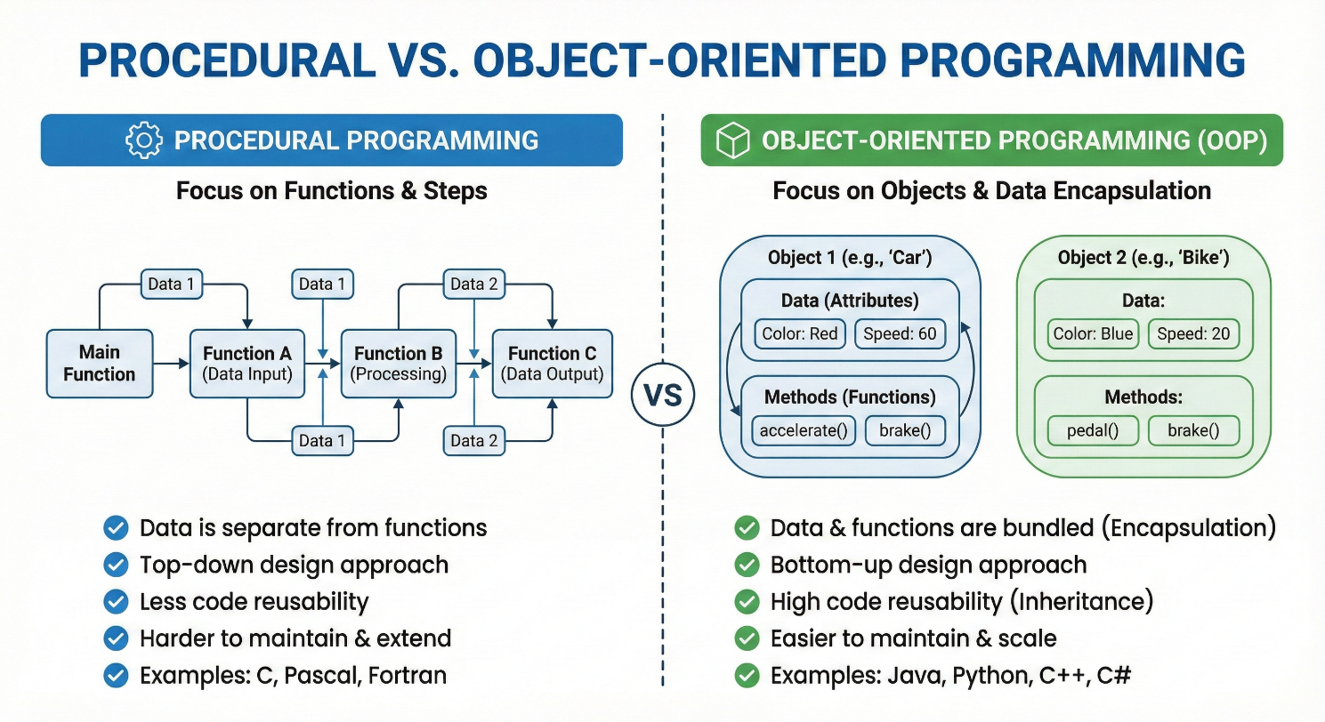

**Key differences:**

* **Structure:** Procedural divides a program into functions; OOP divides a program into classes/objects.
* **Data Handling:** Procedural code passes data between functions (no inherent data hiding). OOP encapsulates data within objects, allowing abstraction and hiding of internal state.
* **Approach:** Procedural is top-down (solve problem step by step); OOP is bottom-up (build objects that interact).
* **Features:** OOP supports inheritance and polymorphism (code reuse through class hierarchies), whereas pure procedural programming has no native inheritance.
* **Use Cases:** Procedural style can be simpler for small or straightforward tasks, while OOP scales better to complex systems by modeling real-world relationships.

**Q3:** List out the features of Python.

**Ans:**

Python is a general-purpose, high-level programming language that was designed to prioritize human readability and developer efficiency. Its "general-purpose" designation means that it is not restricted to a single type of task; rather, it can be applied to a vast array of fields including data science, machine learning, web development, desktop applications, and the Internet of Things (IoT).

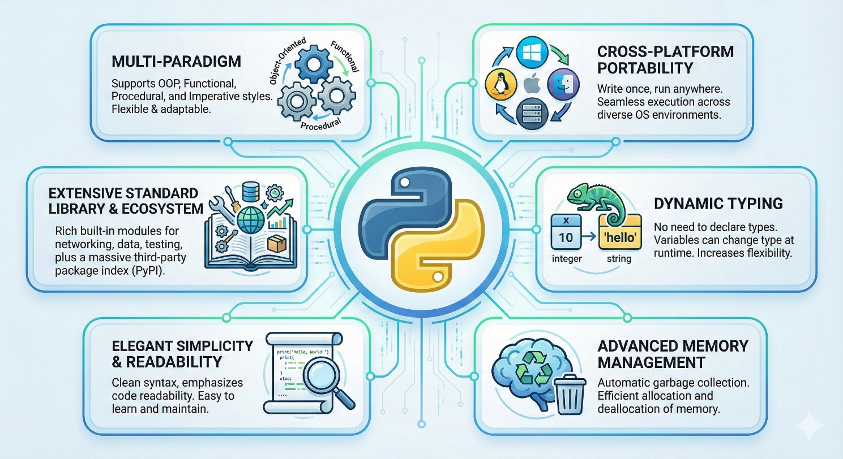

**The following is a detailed examination of the core features that define the language:**

* **High-level, Readable Syntax:** Python is a high-level general-purpose language emphasizing code readability. It uses indentation (whitespace) instead of braces for blocks, and English-like keywords, making code concise and clear.
* **Elegant Simplicity and Readability:** Python follows a philosophy often summarized as "Less Code, More Power," focusing on the logic of an idea rather than complex syntax. It is highly expressive and human-understandable, making it a recommended language for those beginning their programming journey. Python programs are significantly more concise than those written in other popular languages; for instance, a Python program is typically 3 to 5 times shorter than an equivalent Java program and 5 to 10 times shorter than one written in C++. A simple "Hello World" task requires only one line in Python, whereas Java or C might require 8 to 10 lines of boilerplate code.
* **Interpreted Execution and Rapid Development:** Unlike compiled languages like C++ or Java, Python is an interpreted scripting language. A compiler must take an entire program as input and convert it into machine code before any part of it can run, a process that can take minutes or even hours for large projects. In contrast, a Python interpreter processes code line by line, executing each instruction as it is read. This eliminates the time-consuming "compile-fix-compile" cycle, facilitating a very fast "edit-test-debug" cycle. This feature makes Python an ideal tool for initial application prototyping, allowing designs to be clarified quickly before they are potentially re-implemented in a lower-level language for optimization.
* **Dynamic Typing:** Python is a dynamically typed language, which provides immense flexibility compared to statically typed languages like C, Java, or C#. In a statically typed environment, a programmer must explicitly declare the data type of a variable (such as an integer or float) at compile-time, and that type cannot change. Python variables, however, are simply labels given to data values. The interpreter checks the type of a variable during run-time based on the value assigned to it. This allows a single variable to point to an integer at one moment and a string the next, reducing the need for prior type specification and simplifying code structure.
* **Multi-paradigm:** While developing Python, Guido van Rossum borrowed the best features from several existing languages to create a multi-paradigm tool. It supports:
  + **Object-Oriented Programming (OOP):** Borrowed from C++, this allows programs to be organized into objects containing both data and methods.
  + **Functional and Procedural Programming:** Borrowed from C, this enables a top-down approach where programs are divided into reusable functions.
  + **Modular Programming:** Borrowed from Modula-3, this allows code to be divided into small, manageable modules.
  + **Scripting:** Borrowed from Perl and Shell script, making it ideal for automation tasks.
* **Extensive Standard Library and Ecosystem:** Python features a massive standard library that provides a rich set of built-in modules and functions for rapid application development. This allows developers to perform complex tasks "right out of the box" without writing everything from scratch. Furthermore, the Python Package Index (PyPI) serves as an official repository for more than 150,000 third-party libraries, enabling specialized work in scientific computing (NumPy, SciPy), data analysis (Pandas), and artificial intelligence (TensorFlow).
* **Cross-Platform Portability:** Python is a portable, system-agnostic language. Because it uses an interpreter to create "byte-code"—a platform-independent format—it can run equally on different operating systems such as Windows, Linux, Unix, and Macintosh. Any system that has a language-specific virtual machine installed can translate this byte-code into instructions the host computer can understand, meaning a programmer does not have to perform special steps to ensure compatibility across different target environments.
* **Advanced Memory Management:** Python simplifies development by automating low-level system tasks. It includes features like dynamic memory allocation and a built-in garbage collector, which automatically reclaims memory space when an object is no longer referenced. This prevents many common errors associated with lower-level languages where memory must be managed manually by the programmer.
* **"Glue" Language Capability:** Python is uniquely suited to act as a "glue" language, which means it can combine and coordinate components written in different implementation languages. For example, performance-heavy components can be written and compiled in C or C++ and then integrated into a Python application to benefit from both the speed of compiled code and the readability of Python. This is further supported by bindings like Jython (for Java environments), IronPython (for .NET), and MicroPython (for microcontrollers).

These features (simplicity, rich libraries, portability, etc.) make Python suitable for rapid development of many kinds of programs.

**Q4:** What types of applications can be developed by using Python?

**Ans:**

Python is a high-level, general-purpose programming language whose design philosophy emphasizes code readability and allows programmers to express concepts in fewer lines of code than languages like C++ or Java. Because it is a versatile tool, it is utilized across a vast array of technical and professional domains. Common application areas include:

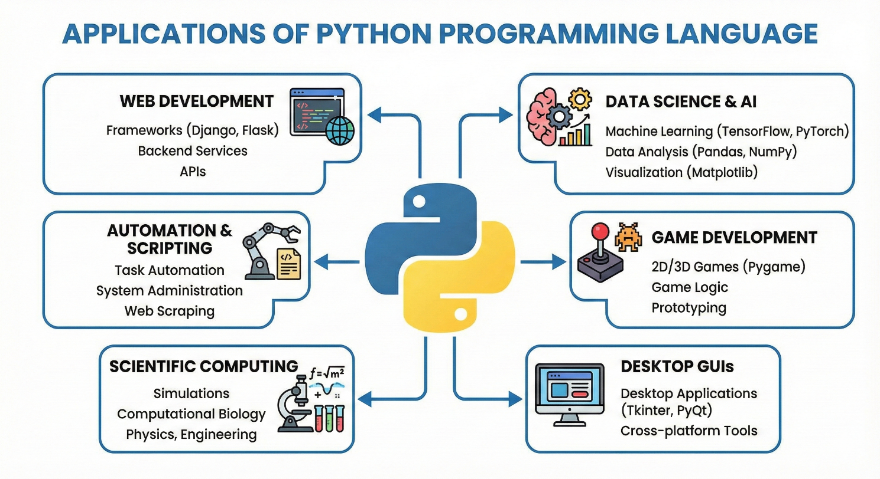

* **Web & Internet Development:** Python is a staple for back-end or server-side development, utilizing powerful web frameworks such as Django, Flask, Pyramid, Bottle, Tornado, Litestar, and web2py to build secure and scalable platforms. It also supports various Content Management Systems (CMS) like Plone and django CMS. The language's extensive standard library and modules provide built-in support for many internet formats and protocols, including HTML, XML, JSON, email, and FTP.
* **Scientific & Numeric Computing:** Python has become a preferred tool for researchers and engineers performing complex data work and scientific simulations. Key libraries in this ecosystem include SciPy for mathematics and engineering, NumPy for handling numeric arrays and matrix calculations, and Pandas for deep data analysis. Additionally, the IPython shell provides an enhanced interactive environment for research, while libraries like matplotlib, scikit-learn, and TensorFlow enable advanced statistics, simulations, and machine learning.
* **Education:** Due to its elegant simplicity, intuitive syntax, and mandatory indentation for readability, Python is highly recommended as a first language for learning to program. It is widely taught in colleges and universities as an introductory language because its programs are typically 3 to 5 times shorter than Java and 5 to 10 times shorter than C++, allowing students to focus on logic rather than complex syntax.
* **Desktop GUI Applications:** Python supports the creation of user-facing software and graphical user interfaces (GUIs) through several specialized toolkits. While tkInter is the standard library for GUI development, other options include PyGObject, PyQt, PySide, wxPython, and DearPyGui. The Kivy framework is specifically highlighted for creating cross-platform interfaces that function on desktops, mobile devices, and touchscreens.
* **Software Development & Scripting:** Python is frequently characterized as a "glue language" because it is designed to integrate and coordinate components written in other languages like C, C++, or Java. It is used extensively for build automation, testing, and professional software tools, including the Buildbot CI server, tracking systems like Trac and Roundup, and build tools like SCons.
* **Business & Enterprise:** Large-scale organizations and mission-critical industries rely on Python for complex tasks and system management. Major entities using Python include Google, NASA, Rackspace, Industrial Lights and Magic, and the Department of Defense. While the sources provided do not explicitly mention the ERP systems "Odoo" or "Tryton," they confirm Python is used for a wide range of business applications and system integration.
* **Automation and Scripting:** Python is often used to automate repetitive common tasks and create shell scripts. It borrowed many of its scripting features from Perl and Shell script, making it ideal for system administration. Key tools for managing infrastructure and system configuration include Ansible, Salt, OpenStack, and xonsh.
* **Game Development:** Python is used in the gaming industry to create interactive environments and handle complex game logic. It allows for the simulation of real-world physics and the modeling of complex visual outputs. Many developers also use Python to provide "modding" interfaces, which allow end-users to customize or manipulate a game without changing the core source code.
* **Internet of Things (IoT):** In the realm of connected devices and robotics, Python is used to program microcontrollers and develop "smart" hardware applications. Specialized versions such as MicroPython and CircuitPython are specifically designed to run in these constrained hardware environments.
* **Application Prototyping:** Because Python skips the time-consuming compilation step and facilitates a rapid "edit-test-debug" cycle, it is considered an ideal tool for initial application prototyping. Developers can quickly build a proof-of-concept version of a program to clarify logic before the design is potentially "hardened" or re-implemented in a lower-level language like C++ or Java for performance optimization.
* **Networking:** Python is utilized to develop networking applications and tools for interacting with various network protocols. It allows for the efficient integration of disparate systems and the handling of data streams across networks.
* **Databases:** Python provides robust tools for database interaction and management. It includes the lightweight SQLite management system by default and supports advanced tools like SQLAlchemy, an object-relational mapper (ORM) that allows developers to interact with databases using Python-centric code rather than raw SQL queries.

**Q5:** Why Python is High-level language?

**Ans:**

Python is classified as a high-level programming language because it is designed to prioritize human readability and programmer efficiency over direct communication with computer hardware. Unlike low-level languages, such as machine level or assembly language, which are difficult for humans to interpret but easy for computers to process directly, high-level languages like Python use English keywords and intuitive syntax that are easily understandable by people.

Several technical characteristics and design philosophies contribute to Python's status as a high-level language:

**Abstraction from Machine Details**

A defining feature of a high-level language is the level of abstraction it provides from the machine's underlying architecture. Python handles low-level system tasks automatically, which allows developers to focus on the logic of their ideas rather than the complexities of hardware management.

* **Automatic Memory Management:** In low-level languages, programmers often have to manually allocate and deallocate memory. Python includes a built-in, cycle-detecting garbage collector and reference counting system that automatically reclaims memory space when an object is no longer in use.
* **Dynamic Memory Allocation:** Python manages the size and storage of data constructs on the fly, meaning the programmer does not need to decide exactly how many bits of memory a variable will occupy during initialization.

**Rich Built-in Data Structures**

Python is considered high-level because it provides complex data structures as native types, sparing developers from the tedious work of building them from primitive components.

* In lower-level languages like C or C++, much of a programmer's time is spent combining primitive types to create useful structures.
* Python offers a wide array of sophisticated built-in types such as lists, dictionaries, sets, and tuples right out of the box. These "compound" data types allow for the efficient organization and manipulation of data without extensive custom coding.

**Dynamic Typing**

Python utilizes a dynamic type system, meaning that variable names are generic reference holders rather than fixed containers for a specific type of data.

* In statically typed (lower-level) languages like C or Java, a programmer must explicitly declare whether a variable is an integer, float, or string before it can be used.
* In Python, variables are simply labels given to any data value. The interpreter checks the type of the variable during run-time, allowing a single variable name to point to a number at one moment and a text string the next without causing an error.

**Concise and Readable Syntax**

The language's design philosophy, often summarized as "Less Code, More Power," emphasizes readability through significant indentation and clear formatting.

* Python programs are typically 3 to 5 times shorter than equivalent Java programs and 5 to 10 times shorter than those written in C++.
* For example, displaying "Hello World" in Python requires only a single line of code, whereas C or Java may require 8 to 10 lines of boilerplate code, including class and main method declarations.
* By using whitespace indentation to delimit blocks of code rather than curly brackets or semicolons, Python ensures that the visual structure of a program accurately represents its logic.

**Interpreted Execution and Portability**

Python is an interpreted scripting language, meaning it does not need to be compiled into machine code before it is run.

* Instead of being converted into machine-specific instructions, Python source code is translated into an intermediate form called byte-code.
* This byte-code is executed by a Python Virtual Machine (PVM), which translates it into instructions the host operating system can understand.
* This makes Python "system agnostic" or portable; a programmer can write code once and run it on Windows, Linux, or macOS without performing special compilation steps for each target environment.

**Role as a "Glue" Language**

Python's high-level nature makes it exceptionally well-suited to act as a "glue language". It is purposely designed to integrate and coordinate components written in different, often lower-level languages like C, C++, or Java. This allows developers to prototype applications quickly in Python and then "harden" or re-implement performance-critical components in a lower-level language for optimization.

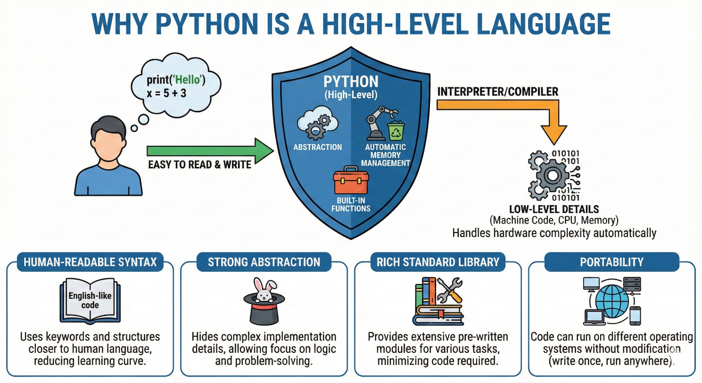

**Q6:** Why Python is “Glue language”?

**Ans:**

Python is specifically defined as a "glue language" because it was intentionally designed to facilitate the seamless integration and coordination of disparate software components written in various other programming languages. It acts as a unifying layer that allows developers to bridge different systems, making it a versatile tool for building complex applications that require diverse technical strengths. The following details explain the specific mechanics and philosophies that contribute to Python's status as a glue language.

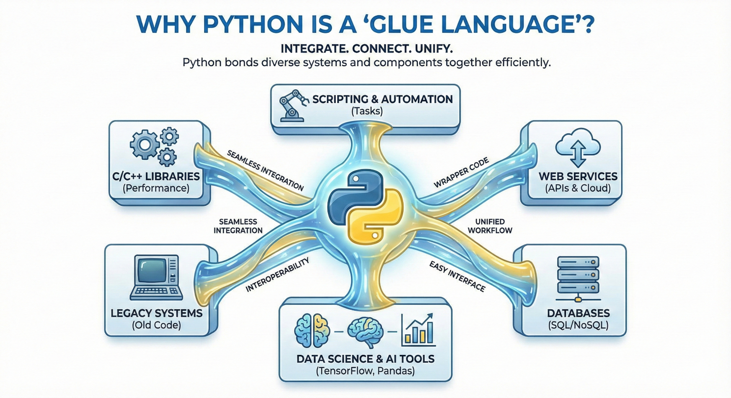

1. **Integration with Performance-Critical Languages**

While Python is an interpreted language and is generally slower in raw execution than compiled languages like C or C++, it is frequently used to "glue" together components written in those lower-level languages. Developers often write performance-intensive logic or hardware-interfacing code in C++ and then use Python to manage the high-level logic and data flow between these modules.

* **Library Implementations:** Many high-performance Python libraries, such as NumPy, utilize this glue capability by running C or Fortran "under the hood" while providing a readable Python interface to the user.
* **Development Speed:** This approach prioritizes developer efficiency; anecdotal evidence suggests a Python programmer can complete in two months what might take two C++ programmers a full year to finish, simply because the Python "glue" is so much easier to write and debug.

1. **Cross-Language Bindings and Implementations**

Python is extremely compatible with inter-language programs because it offers specialized bindings for non-native environments. These implementations allow Python to act as the primary interface for systems built on entirely different frameworks:

* **Jython:** This implementation allows Python to call Java code and vice versa by translating Python source code into Java bytecode, which is then managed by a run-time library to support Python’s dynamic nature.
* **IronPython:** This serves as a bridge to the .NET framework, allowing Python to integrate with applications written in languages like C#.
* **MicroPython/CircuitPython:** These variants allow Python to act as the glue for hardware-level applications on microcontrollers, simplifying the programming of embedded systems.

1. **Prototyping and "Hardening" Workflow**

Python’s status as a glue language makes it the ideal tool for initial application prototyping. Because Python code is typically 3 to 5 times shorter than equivalent Java code and up to 10 times shorter than C++, designs can be clarified and tested rapidly. Once the logic is finalized, specific performance-bottleneck components can be "hardened"—meaning they are re-implemented in a lower-level language for optimization—while the rest of the application remains glued together by Python.

1. **Scripting Interfaces for End-Users**

Using Python as a glue language allows developers to provide a scripting interface to the end-user without exposing the entire source code. This is common in complex software like video games or professional modeling tools, where the core engine might be written in C++, but Python is used to allow "modding" or customization. This enables users to manipulate data and actions on the fly through simple Python scripts while the heavy lifting is handled by the underlying "glued" system.

1. **Multi-Paradigm Compatibility**

Python is uniquely positioned as a glue language because its very design is a hybrid of features borrowed from other languages. Guido van Rossum incorporated diverse programming paradigms into Python's core:

* Functional programming features were taken from C.
* Object-oriented programming (OOP) features were derived from C++.
* Scripting language features were borrowed from Perl and Shell script.
* Modular programming features were taken from Modula-3.

By synthesizing these features into a single, straightforward syntax, Python is naturally expressive and capable of interacting with codebases that use any of these structures. This makes it highly effective at integrating systems that would otherwise be difficult to combine due to conflicting programming styles.

**Q8:** Execution Process of Python Program?

**Ans:**

The execution of a Python program follows a sophisticated, multi-stage process that distinguishes it from purely compiled languages like C or purely interpreted languages. Python utilizes a traditional runtime execution model where source code is translated into an intermediate form before being processed by a virtual machine.

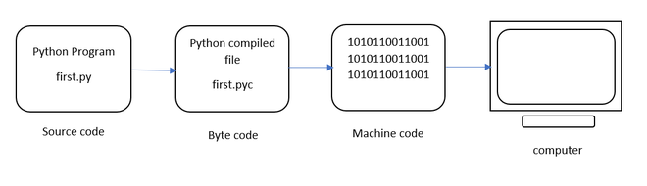

1. **Source Code and Compilation to Bytecode**

The process begins when a programmer writes instructions in a plain text file, typically saved with a .py extension. When this script is executed, the Python interpreter first performs an automatic compilation step. Unlike languages that compile directly to machine-specific code, Python translates the source code into an intermediate, platform-independent format known as bytecode.

* **Bytecode Characteristics:** This bytecode is a lower-level, numeric representation of the program that is easier and faster for a computer to execute than the original high-level source code.
* **Storage:** These compiled bytecode files often carry a .pyc extension.
* **Import Logic:** If a program involves importing modules, the interpreter first checks a cache called sys.modules to see if the module has already been imported. If not, it searches the sys.path for the file and compiles it into bytecode.

1. **The Python Virtual Machine (PVM)**

Once the bytecode is generated, it is sent to the Python Virtual Machine (PVM). The PVM is not a physical machine but a software-based runtime engine that serves as the final step of the execution process.

* **Instruction Translation:** The PVM’s sole purpose is to iterate through the bytecode instructions and translate them into machine code instructions that the host operating system (such as Windows, Linux, or macOS) can actually understand.
* **System Agnosticism:** Because the bytecode itself is system-independent, any computer with a version-compatible PVM installed can execute the same .pyc files, making Python a "system agnostic" or portable language.

1. **Line-by-Line Interpretation**

Python is fundamentally classified as an interpreted language because the PVM processes the bytecode line by line at runtime. This approach differs significantly from compiled languages:

* **Execution vs. Compilation:** In compiled languages (like C or Java), a compiler must read the entire program and convert it into machine code before any of it can run. In Python, the interpreter takes one line of the program as input at a time, converts it, and executes it immediately.
* **Error Detection:** Because execution happens line-by-line, the interpreter displays errors immediately after a faulty instruction is read. This facilitates a rapid "edit-test-debug" cycle, as developers do not have to wait for a lengthy full-program compilation to identify syntax or logic issues.

1. **Runtime Management: Typing and Memory**

As the PVM executes the code, it handles two critical background processes:

* **Dynamic Type Checking:** Python uses "late binding" or dynamic name resolution. This means the type of a variable (e.g., integer, string) is not known at compile-time but is checked and assigned during runtime based on the value given to the variable. Variables in this stage act as labels pointing to objects in memory rather than fixed containers.
* **Memory Management and Garbage Collection:** During execution, Python automatically manages memory through a combination of reference counting and a cycle-detecting garbage collector. The interpreter tracks how many references exist for every object; when an object is no longer referenced (such as when a local variable goes out of scope), the garbage collector automatically reclaims that memory space.

1. **Summary of the Workflow**

The detailed flow can be visualized as follows:

1. **Source Code:** Programmer creates the .py file.
2. **Compilation:** The interpreter translates the .py source into intermediate .pyc bytecode.
3. **Virtual Machine:** The PVM reads the bytecode and translates it into machine-specific instructions for the OS.
4. **Runtime Execution:** The code runs line-by-line, managing variable types and memory usage automatically as it proceeds.

